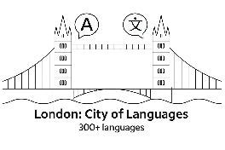
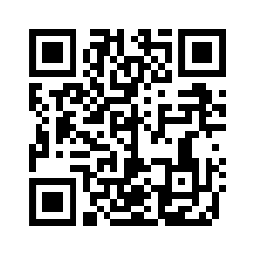
London Festival of Languages 2026

Poster Competition
londoncityoflanguages.org.uk/festival/

London: City of Languages is coordinating a ‘London Festival of Languages 2026’. The Festival will include a wide variety of activities, both online and face to face, when we can celebrate the rich diversity of languages used, studied, and loved across our city.

To advertise this, we need a set of posters to display in schools, cultural organisations and public spaces (e.g. libraries) to encourage people to go to our Festival of Languages Page on the website to find out what is on offer.

We invite pupils across London to design posters. Winning posters will be shared online and made available for schools and communities to download and use during the Summer Festival of Languages. Please note: we welcome adapted versions of submissions for the logo competition

What to include in the poster
(1) “London Festival of Languages, Summer 2026”
(2) “Find out more:” followed by a QR code (see above) or web address: londoncityoflanguages.org.uk/festival/
(3) Images/ text which celebrate the multiplicity of languages spoken and used in London (rather than nations / countries / flags)

Who can enter: Pupils from primary, secondary, sixth form, supplementary and complementary schools across London.

Format
- A4 or A3 poster
- Pupils may draw by hand or use basic digital design software
- Hand-drawn posters must be clearly scanned or photographed to a digital format: JPEG, PNG, or PDF (up to 5MB)
- Original work: All entries must be the pupil’s own original work
- No AI-generated designs and no copyrighted images

Submission: Teachers should submit entries on behalf of pupils using the online form on our website and upload the poster file. A 5-minute video on how to do this is here - it describes how to upload for another competition, but the process is the same). Once your workspace is set up, each entry takes 1 minute].We thank teachers for taking the time to do this. If you have any queries, please contact us via our email: info@londoncityoflanguages.org.uk

Deadline: Midnight, Monday 20th April 2026

Judging & recognition:
- Posters will be judged on creativity and representation of London as a City of Languages
- Winning posters will feature on our website and resources. We will add our logo to them.
- Winners will receive a printed or framed copy of their poster
- All participants receive a certificate
- A gallery of selected entries will be displayed online.

Usage rights
By entering, pupils and schools grant London: City of Languages permission to use and edit submitted posters for publication and promotional purposes.

We look forward to seeing your posters!

