**European Week of Languages 2025**

**Languages Open Hearts and Minds**

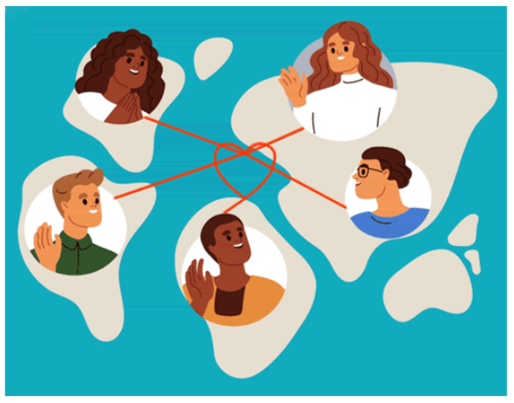Speaking and learning languages harnesses both the emotions and the brain. As well as boosting brain power and connecting people, learning languages facilitates the exchange of ideas, emotions, and experiences – strengthening empathy and respect for different ways of life and as such is a powerful tool to promote world peace. At The Grey Coat Hospital we celebrate the linguistic diversity and curiosity to learn which makes our community so strong.

|  |  |
| --- | --- |
| **St Andrew’s** | **St Michael’s** |
| **MONDAY 22 September**  **Mandarin** with  **Twi, Fante, Ga, Kikuyu** with | **MONDAY 22 September**  **KS5 Spanish Current Affairs** - open to KS4 keen linguists for the first session, |
| **TUESDAY 23 September**  Introduction to **Ancient Gree**k with **Modern Greek** counterpoint  **Russian** with | **TUESDAY 23 September**  **French Thinkers Club** – An introduction to Foucault led by |
| **WEDNESDAY 24 September**  **Diversity and Inclusion** – from a Languages and Cultural Perspective including **Yoruba** with  **French** with | **WEDNESDAY 24 September**  **Italian** with  **Cryptic Crosswords** with |
| **THURSDAY 25 September**  **Spanish** KS3 Club  **Japanese** | **THURSDAY 25 September**  **Romanian** with |
| **FRIDAY 26 September**  **World-a-oke** karaoke in another language celebration  **German** with  **Brandenburg Philharmonic Orchestra Special Concert** **3pm-4.30pm** | **FRIDAY 26 September**  **The EPQ / IRP: Linguistic Policy and Colonialism (French Focus)** |

**COMPETITIONS: LONDON CITY OF LANGUAGES LOGO DESIGN, GCH COOKERY BOOK, ISLAMIC TILE DESIGN... Get Involved!!!**